Software

Requirements Specification

For

4 x Gen4L-block Tester software

Version 04

|  |  |  |
| --- | --- | --- |
|  | **Name** | **Date** |
| Written by: | Meir Bar Nathan |  |
| Approved by: |  |  |
| Version No: | Version 02 | 5-11-2013 |
|  | Version 03 | 13-11-2013 |
|  | Version 04 | 18-11-2013 |

* **Overview**

The Gen4L tester program will allow a comprehensive testing of the Gen4L-based print-block. The hardware configuration of the tester will be based on the electronics designed for the printer, namely, OHDB 2 + GEN4L Head driver Board. Some changes to the OHDB firmware may be needed in order to support the tester functionality.

The tester program can be based on the existing Eden Tester software which will undergo changes emanating from the requirements presented in this document.

* **Tester functions**
  1. **Temperature control**
     1. Set temperature for 4 ptintheads, each containing ODD and EVEN heaters (8 heaters altogether). The temperature set value will be entered in ADU.
     2. Set temperature for 4 channel block heaters (pre-heater1/2, block front/rear).
     3. Actual printheads and block temperature reading display in ADU (8+4 channels)
     4. Set error margin. The error margin will be defined in ADU (e.g. 100). The margin includes 2 parameters – Low limit and High limit. If the actual temperature value (in ADU) > High or < Low, the nackgroung of the relevant actual value will turn red. Otherwise it will be green.
     5. Heater ON/OFF control (global).This button enable/disable the heating of all channels.
     6. Individual Enable / Disable control for each heater.
     7. Temperature ramp-up control. The allowed ramp-up rate is 0.5°C/ sec (22ADU/sec) See flow chart for ramp up algorithm. This algorithm should only be implemented during the heating up of a cold head (warmup). The ramp up vcontrol will be active only if the current temperature is below 50°C (AD=3200).
  2. **Data setting**
     1. Individul nozzle setting for each of the 4 printheads (4 x 384 nozzles).
     2. Set ALL/Clear ALL control for all printheads.
     3. Set/Clear data for a group of nozzles (GUI dependent).
     4. Load/Save pattern capability.
     5. Cyclic data generation (cyclic ON/OFF pattern).
        1. Parameters for cyclic data:
           1. Start nozzle
           2. End Nozzle
           3. # ON, #OFF
  3. **Strobe LED control**

The setting of the delay between the Fire pulse and the LED drive-pulse can be manually and interactively controlled by the user.

The GUI will be based on a slider as shown in the picture below:

200µS

0µS



Min delay = 0µs

Max delay= 200µs

Resolution = 1µs

The parameter sent to the firmware of the OHDB will be calculated by the following formula: *Delay time /T clock cycle*

HW perspective:

To use this feaure we use two registers:

WR_STRB_DLY, address 1Ah, that defines the delay between the fire pulse and strobe pulse. This enables writing to a counter that ist value ist he calculated delay.

Because a 1usec resolution is needed, a clock of 2.08MHz is being used (CLKDIV16)

Strobe pulse width is defined by register WR_STRB_W, address 1Bh. This enables writing to a 9bit counter for the strobe width.

Strobe width can be changed between 0 to 10usec at steps of 100nsec. A basic system clock of 33.33MHz (MCLK) is being used to answer those demands.

To enable stobe mechanism, use DIAG12 (WR_DIAG1, address 04h, bit 12). „1“ – operates strobe, „0“ – disable it.

* 1. **Fire control**
     1. Fire frequency setting
     2. Fire Mode setting
        1. Continuous
        2. Duty cycle (# of fires ON, # of fires OFF, # of cycles)
        3. Single burst (# of fires)
        4. Firing for a set time duration

Formula for conversion of time to # of fires:

*# of fires = time (sec) x frequency (Hz)*

HW perspective:

Number of fires on and number of fires off defined in 4 registers: two 16bits registers for on and two 16bits registers for off. This is because the amount of pulses needed, and the ability of writing only to 16bits registers.

WR_FIRES_ON1, address 37h, defines the 16bits MSB of „ON“ register.

WR_FIRES_ON2, address 38h, defines the 16bits LSB of „ON“ register.

WR_FIRES_OFF1, address 39h, defines the 16bits MSB of „OFF“ register.

WR_FIRES_OFF2, address 3Ah, defines the 16bits LSB of „OFF“ register.

WR_FIRES_CYCLS, address 3Bh, defines the number of cycles for the wanted duty-cycle.

Single burst is a cycle of one. The user needs to write the number of fires in the „ON“s registers and „1“ for number of cycles.

**Continues mode** and **firing for a set of time** are achieved by using DIAG5 (WR_DIAG1, address 04h, bit 5). When it is „1“, the fire will continue, regardless of the values in „ON and „OFF“ registers. To stop firing (manually or after a period of time), disable DIAG5 (writing „0“).

For the formula above, frequency of 33.33MHz is being used.

* 1. **Head voltage control** 
     1. Calibration of head voltage (4 x 2 channels) (see appendix B)
     2. Actual voltage reading
     3. Error indication
     4. Heads PS voltage reading

HW perspective:

Because we are using 30pin connector for GEN4 head drive, there is a shortage of pins for all GEN4 signals.

GEN4 head assemble from two 192 nuzzles heads.

For every head there is, on the head drive, a dedicated power supply for the pulser voltage.

There is a feedback of this voltage, but because we have only one pin for this voltages reading, we are using analog multiplexer.

To achieve the pulser voltage reading (Vpp) from all eight heads, there is a 3bit register, WR_VPP_MUX, address 1Eh, that controls a 3-to-8 decoder. For reading each head’s pulser voltage, use the following table:

|  |  |  |  |
| --- | --- | --- | --- |
| **D2** | **D1** | **D0** | **Reading** |
| 0 | 0 | 0 | Head1 pulser voltage |
| 0 | 0 | 1 | Head2 pulser voltage |
| 0 | 1 | 0 | Head3 pulser voltage |
| 0 | 1 | 1 | Head4 pulser voltage |
| 1 | 0 | 0 | Head5 pulser voltage |
| 1 | 0 | 1 | Head6 pulser voltage |
| 1 | 1 | 0 | Head7 pulser voltage |
| 1 | 1 | 1 | Head8 pulser voltage |

* 1. **Resin-fill control**
     1. Setting threshold values for all 4 sensors or for all 6 sensors in case where a “flooding“ reservoir is being used.
     2. Setting hysteresis value
     3. Enable/disable control
     4. Setting timeout period
     5. Timeout error indicator
     6. Pump Active indicator for every one of the materials
     7. Setting of operating mode. Select between “flood“ mode and 4-material mode. In case of a“flood“ mode – selection of material source (pump assignment).
  2. **Vacuum and purge control**
     1. Vacuum valve On/Off control
     2. Setting purge duration
     3. Purge On/Off control
     4. Air Valve actuator
     5. Actual vacuum sensor readout
  3. **Fire pulse builder**

The Pulse Builder is a tool for setting the pulse parameters. It will be capable of handling single and double pulse configurations. 8 sets of parameters will be sent to the H/W (1 set for each half of the printhead).

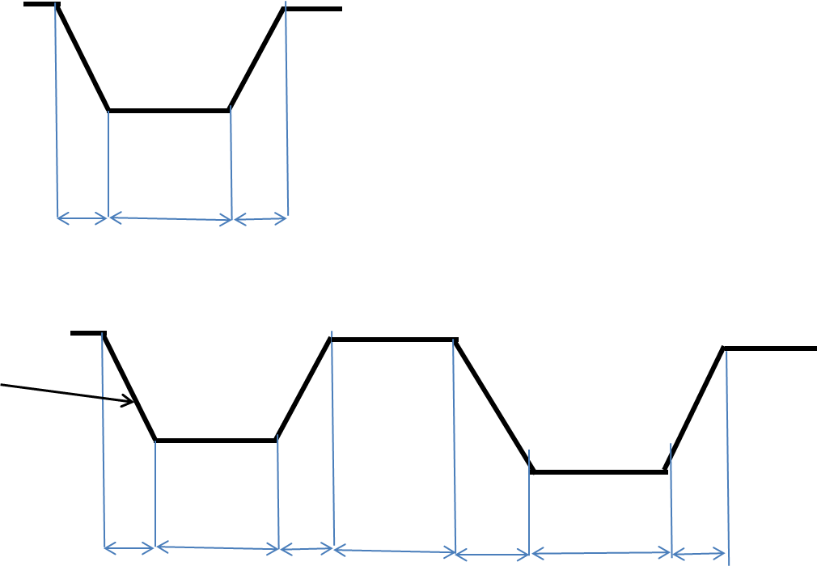

Dwell

RT

FT

Interval

* + - * + **Pulse parameters**
        + For each pulse the following parameters should be user defined:

Pulse width (user defined through GUI)

% of voltage (the voltage that has been calibrated) – double-pulse only.

T_resonance (acoustic resonance cycle time in µs)

* + - * + **Double pulse**

In this mode the calculation of the dwell time and the pulse interval will be done automatically depending on the the voltage and pulse width. Those parameters will be sent to the H/W after calculation. The following formulae to calculate the above parameters:

*Dwell time = Pulse width - Voltage x % of voltage / slew rate*

Another parameter that will be required by the firmware is the lapse time between the start of the pulse and the trancation point. It will be calculated using the following formula:

*Tdelay* = *Voltage x % of voltage / slew rate*

The interval will be calculated by the following formula:

*Interval = T_resonance – Pulse width*

HW perspective:

The pulses structure is achived by 5 registers, for every head –

WR_PLS1_FTx – x can be in range of 1 to 8 (for every head), addresses B0h – B7h (every address number for every head – B0h for head1, B1h for head2 etc.)

This register enables a writing to a 8bit counter defines the fall time (F.T.) period of the pulse. The typical value recommended by Ricoh spec is 2.5usec. therefor the counter is using 33.33MHz clock.

WR_PLS2_FTx, addresses B8h-BFh, is the same as above, but for pulse 2 at double pulse mode.

WR_PLS1_DWELLx - x can be in range of 1 to 8 (for every head), addresses C0h – C7h (every address number for every head – C0h for head1, C1h for head2 etc.)

This register enables a writing to a 8bit counter defines the dwell time (Dwell) period of the pulse. The typical value recommended by Ricoh spec is 3.5usec. therefor the counter is using 33.33MHz clock.

WR_PLS2_DWELLx, addresses C8h-CFh, is the same as above, but for pulse 2 at double pulse mode.

WR_PLS12_DLYx - x can be in range of 1 to 8 (for every head), addresses D0h – D7h (every address number for every head – D0h for head1, D1h for head2 etc.).

This register enables a 8bit counter defines the interval time (Interval) period between the two pulses. A clock of 33.33MHz is being used for this counter.

At single pulse mode, because every head has its own set of parameters, and even if all heads using the same set of parameters, the software still needs to update the first pulse parameters for every head, i.e. 16 registers (2 for each head). The parameters for the second pulse and interval is not applicable and won’t be use.

* 1. **Actuators** 
     1. Material pumps
     2. LED illumination
     3. Waste pump
  2. **Communication setup**



**Appendix A** – warm-up

**Appendix B** – voltage calibration

* Background

The process (described in the flow chart below) includes the following steps:

* 1. Requested-voltage entry
  2. Check if voltage is in range
  3. Calculate potentiometer value for the requested voltage
  4. Calibrate voltage
  5. Save potentiometer value obtained after the calibration in the machine parameters.
* Parameters

|  |  |
| --- | --- |
| Parameter | value |
| R1 - Model | 12 |
| R2- Model | 1 |
| Vref | 2.5 |
| Min_V | 19V |
| Max_V | 33V |

* Implementation
  1. formulae
     1. Potentiometer- value calculation formula

N = $\frac{\left(R2+1\right)×\left(RV-Vref\right)-R1×Vref}{RV}×256$

***RV*** – requested voltage

**4.2. Calibration process**

The process is described in the following flow chart (the process is identical for both support and model heads, except for the parameters).

**Version control:**

|  |  |  |
| --- | --- | --- |
| Version 01 | 1-6-2013 | draft |
| Version 02 | 5-11-2013 | Initial version |
| Version 3 | 13-11-2013 | Auto voltage range setting cancelled |
|  |  |  |